I. ETL OBJECTIVES
To bridge the operational source and the analytical repository, an enterprise-grade automated Data Pipeline was designed and implemented in SSIS to achieve four core objectives:
- Extract: Get lots of historical data from CompanyX without slowing down their everyday transactions. This includes things like transaction headers, line items, and promotional information. We can take in all this data without interfering with their normal operations.
- Transform: Compute runtime additive financial metrics (GrossSales, DiscountAmount, and NetSales) in-memory, sanitize unmatched or null promotion keys via dual-branch routing, and map operational natural keys to surrogate keys.
- Load: To get the best results, you need to load data into the main sales table, called FACT_SALES_LINE, really fast and make sure all the related information in the other tables, like the ones for promotions, matches up perfectly. This is important for the DW_Promotion_Analytics system to work smoothly.

II. ARCHITECTURAL DESIGN & SOURCE SYSTEM MAPPING (COMPANYX)

1. Target Star Schema Architecture (DW_Promotion_Analytics)

The analytical repository conforms strictly to Ralph Kimball’s dimensional modeling methodology:
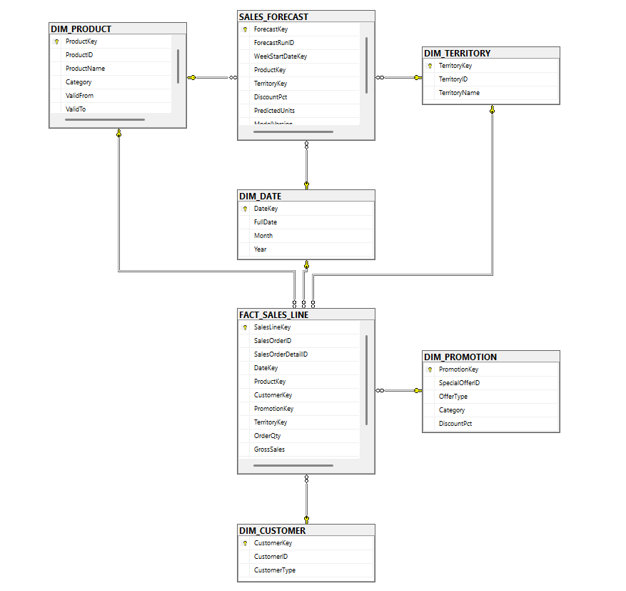

Central Fact Table: FACT_SALES_LINE declared at the line-item grain (one individual record per scanned product line on a sales receipt).

Conformed Dimensions:

DIM_PROMOTION: Captures discount percentages, promotional mechanics, and marketing campaign categories. Contains a dedicated default surrogate record (PromotionKey = 0) representing organic baseline sales ("No Discount").

DIM_PRODUCT: Implements Slowly Changing Dimension (SCD) Type 2 tracking logic (ValidFrom, ValidTo, IsCurrent) to retain historical product category assignments and avoid retroactive revenue distortion.

DIM_CUSTOMER: Segregates buyers into distinct channel entities (B2B Reseller vs. individual B2C Consumer).

DIM_TERRITORY: Represents regional geographical hierarchy and store territories.

DIM_DATE: Formats operational transaction timestamps into an 8-digit surrogate integer key (DateKey as YYYYMMDD).

2. Source-to-Target Data Mapping from CompanyX
- Transactional Grain: Joined from CompanyX.Sales.SalesOrderDetail and CompanyX.Sales.SalesOrderHeader.
- Promotional Schemes: Synchronized from CompanyX.Sales.SpecialOffer into DIM_PROMOTION.
- Date Surrogate Key (DateKey): Extracted from h.OrderDate and formatted as an 8-digit integer (YYYYMMDD) using CAST(CONVERT(VARCHAR(8), h.OrderDate, 112) AS INT).

III. SSIS DATA FLOW PIPELINE IMPLEMENTATION
The core loading workflow was engineered within the Data Flow Task DFT_Load_FactSalesLine. To prevent constraint failures on non-discounted transactions and provide an exact baseline for promotional lift analysis, the architecture implements a Dual-Branch Lookup Routing pattern:
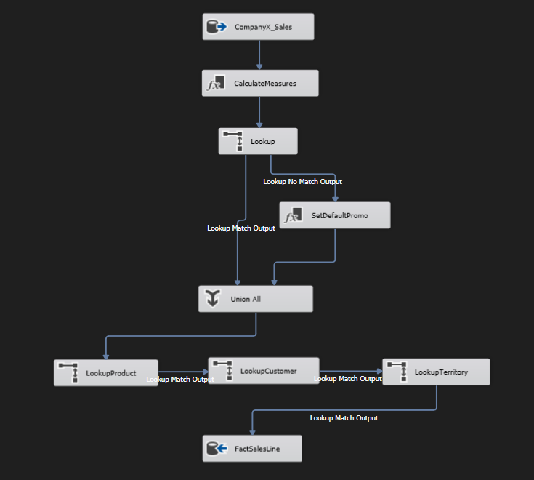

1. OLE DB Source (CompanyX_Sales)
- Connection Manager: LocalHost.CompanyX using the MSOLEDBSQL OLE DB driver.
- Data Access Mode: SQL command.
- Extraction Query:
SELECT
d.SalesOrderID,
d.SalesOrderDetailID,
CAST(CONVERT(VARCHAR(8), h.OrderDate, 112) AS INT) AS DateKey,
h.CustomerID,
h.TerritoryID,
d.ProductID,
ISNULL(d.SpecialOfferID, 1) AS SpecialOfferID,
d.OrderQty,
CAST(d.UnitPrice AS FLOAT) AS UnitPrice,
CAST(d.UnitPriceDiscount AS FLOAT) AS UnitPriceDiscount
FROM CompanyX.Sales.SalesOrderDetail d
JOIN CompanyX.Sales.SalesOrderHeader h ON d.SalesOrderID = h.SalesOrderID;
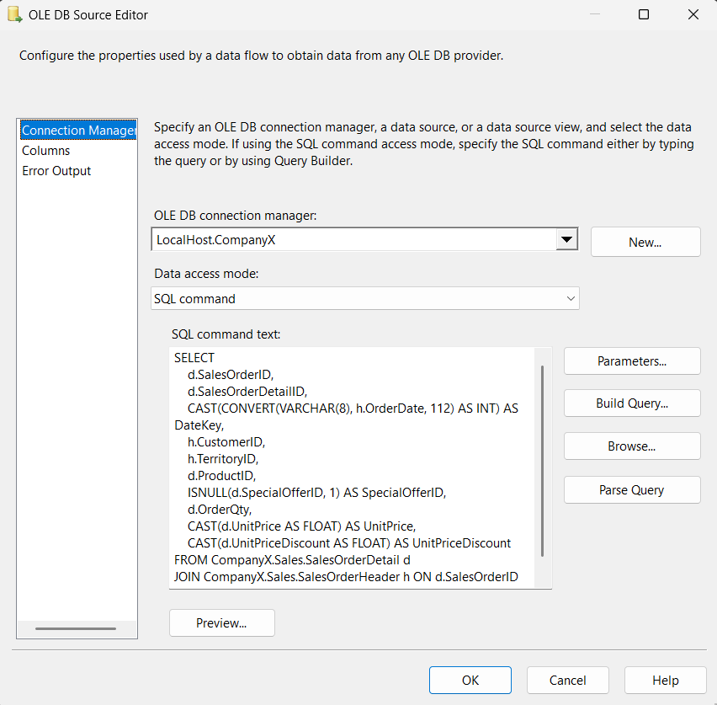

2. Derived Column Transformation (CalculateMeasures)
To eliminate rounding issues and prevent decimal truncation errors, calculations are performed in-memory utilizing double-precision 64-bit floating points (DT_R8):
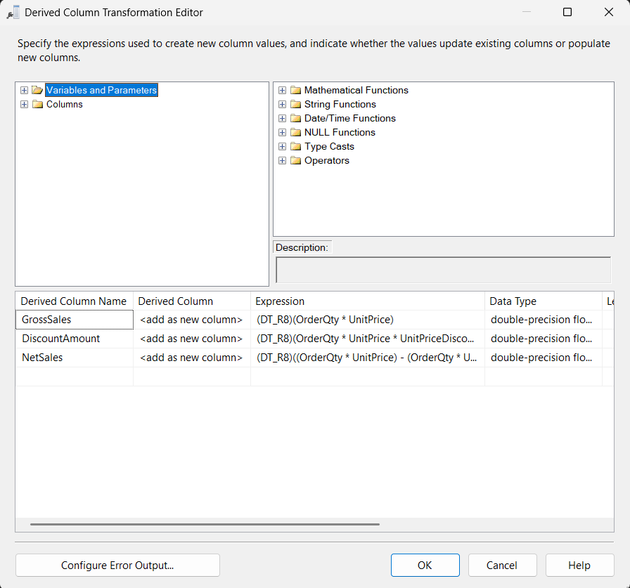
- GrossSales (Gross Revenue before deductions):
$(DT_R8)(OrderQty×UnitPrice)$
- DiscountAmount (Absorbed promotional markdown):
$(DT_R8)(OrderQty×UnitPrice×UnitPriceDiscount)$
- NetSales (Actual recognized cash revenue):
$(DT_R8)((OrderQty×UnitPrice)-(OrderQty×UnitPrice×UnitPriceDiscount))$

3. Lookup Transformation (Lookup)
- Objective: Translate the operational natural key (SpecialOfferID) into the warehouse surrogate key (PromotionKey) by querying DIM_PROMOTION.
- Caching Strategy: Full cache (pre-loads reference dimension data into RAM ahead of pipeline execution, maximizing throughput across large transaction sets).
- Join Specification: Matches incoming SpecialOfferID against DIM_PROMOTION.SpecialOfferID to retrieve PromotionKey.
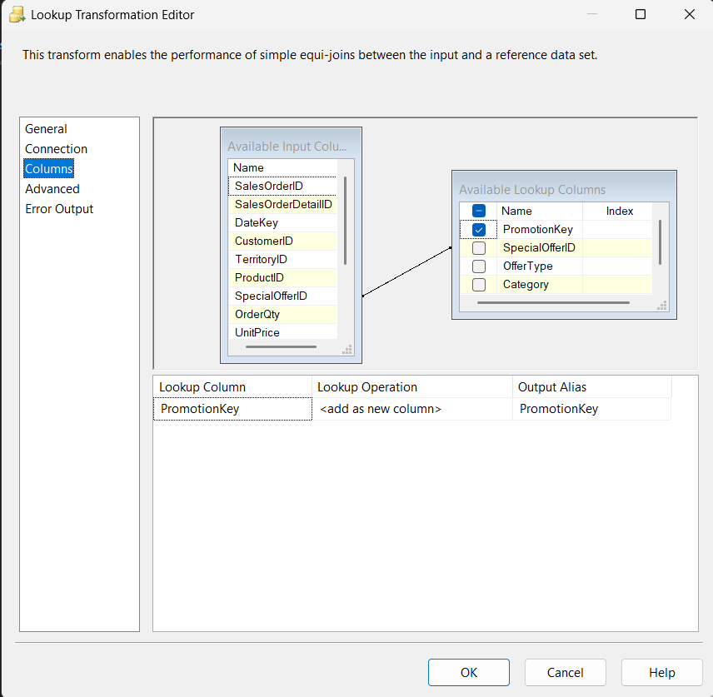
Exception Handling & Routing Logic:
- Replaced the legacy Ignore failure configuration with Redirect rows to no match output to explicitly decouple regular transactions from active promotions.
- Lookup Match Output: Routes qualified promotional transactions directly to the consolidation stage (UNI_CombineSalesData).
- Lookup No Match Output: Redirects all non-matching rows (standard retail transactions sold at catalog price) to a dedicated enrichment step (DER_SetDefaultPromo).
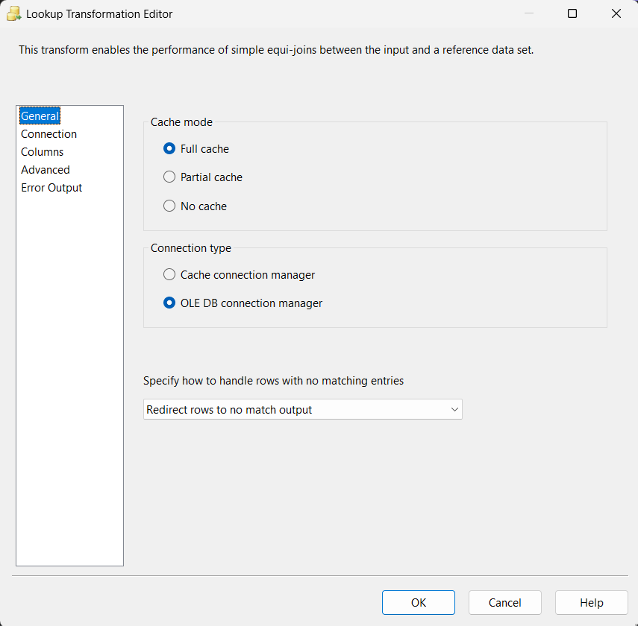

4. Secondary Derived Column Transformation (SetDefaultPromo)

Objective: Extracts unmatched records from the Lookup No Match Output stream and supplies a standardised default dimension key without altering any non-null constraints or referential integrity present.

Transformation Parameters:

Derived Column Name: PromotionKey

Derived Column: <add as new column>

Expression: (DT_I4)0

Data Type: Four-byte signed integer (DT_I4)
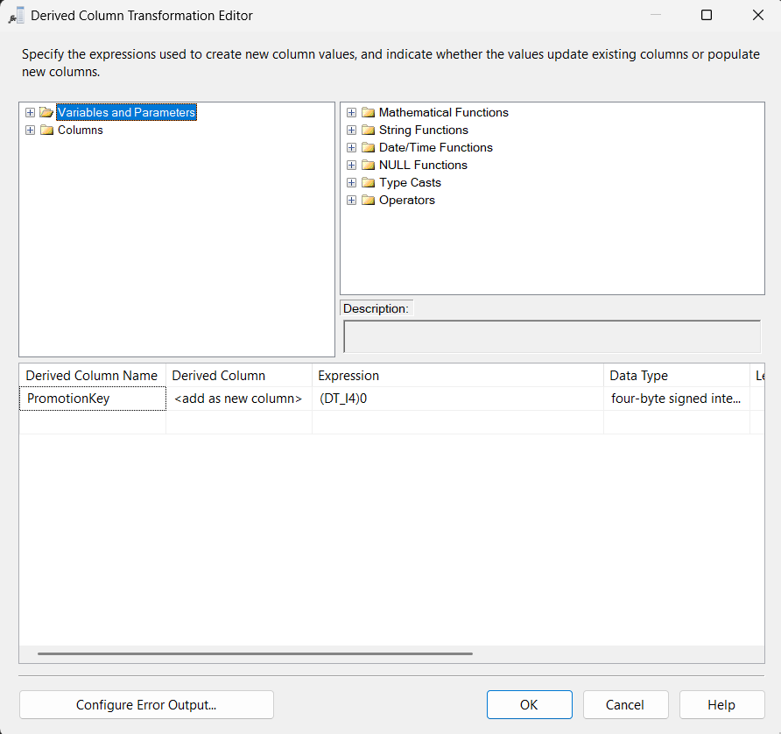

Business Justification: By setting PromotionKey = 0 (to reference the conformed ‘No Discount' dummy item in DIM_PROMOTION), a sales volume baseline is created that is not contaminated with promotions to help measure true Promotion Lift (95.52% of all orders). Assigning PromotionKey = 0 (pointing to the conformed 'No Discount' dummy member in DIM_PROMOTION) establishes an unpolluted baseline sales volume (95.52% of total orders) essential for measuring true Promotion Lift.

5. Union All Transformation (Union All)

Objective: Consolidates the dual-branch data streams back into a single unified pipeline prior to database insertion:

Input 1: Promotional orders originating from Lookup Match Output (PromotionKey != 0).

Input 2: Baseline regular-price orders originating from DER_SetDefaultPromo (PromotionKey = 0).

Metadata Alignment: Guarantees uniform schema structure and consistent data types across all pipeline streams.

6. Lookup Product Transformation (LookupProduct)
- Objective: Map incoming operational product identifiers (ProductID) to the conformed surrogate key (ProductKey) by querying DIM_PRODUCT, harmonizing dimensional keys under an SCD Type 2 architecture.
- Caching Strategy: Full cache (pre-loads reference dimension data into RAM ahead of pipeline execution, maximizing throughput across large transaction sets).
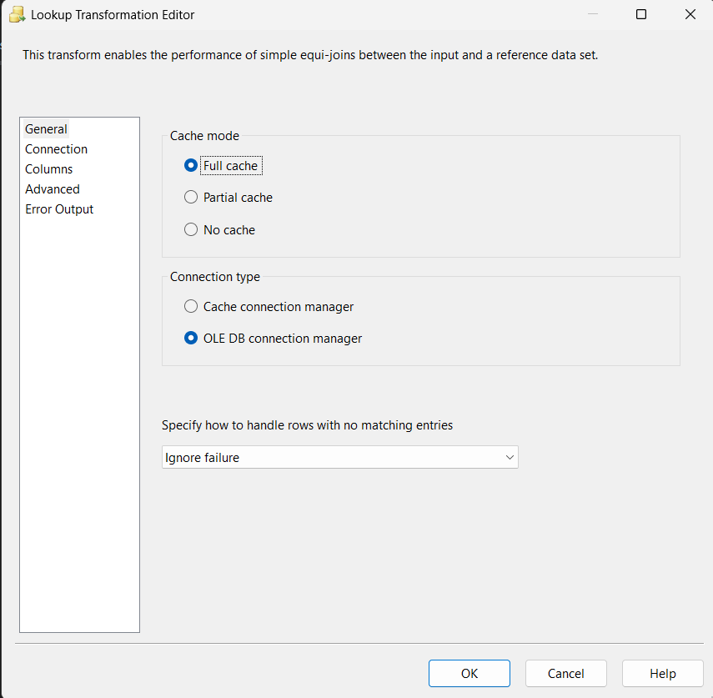
- Join Specification: Matches incoming ProductID against DIM_PRODUCT.ProductID to retrieve ProductKey.
- Transformation Parameters & Added Columns:
  - Lookup Column: ProductKey
  - Lookup Operation: <add as new column>
  - Output Alias: ProductKey
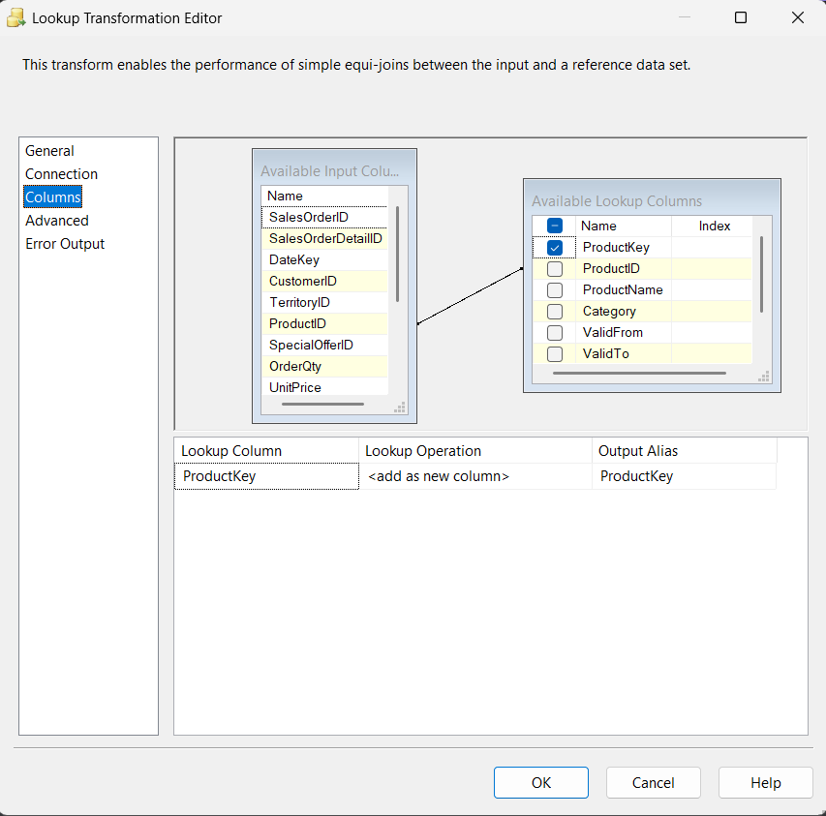
- Exception Handling & Routing Logic:
  - Configured with Ignore failure to maintain pipeline continuity against transient product records.
  - Lookup Match Output: Routes all successfully matched line items to the downstream customer resolution stage (LookupCustomer).

7. Lookup Customer Transformation (LookupCustomer)
- Objective: Join incoming operational product identifiers (ProductID) to conformed surrogate key (ProductKey), using the dimensional table DIM_PRODUCT, and applying an SCD Type 2 architecture.
- Caching Strategy: Full cache (Pre-loads reference dimension data in RAM before pipeline is executed, to maximize throughputs over large transaction sets).
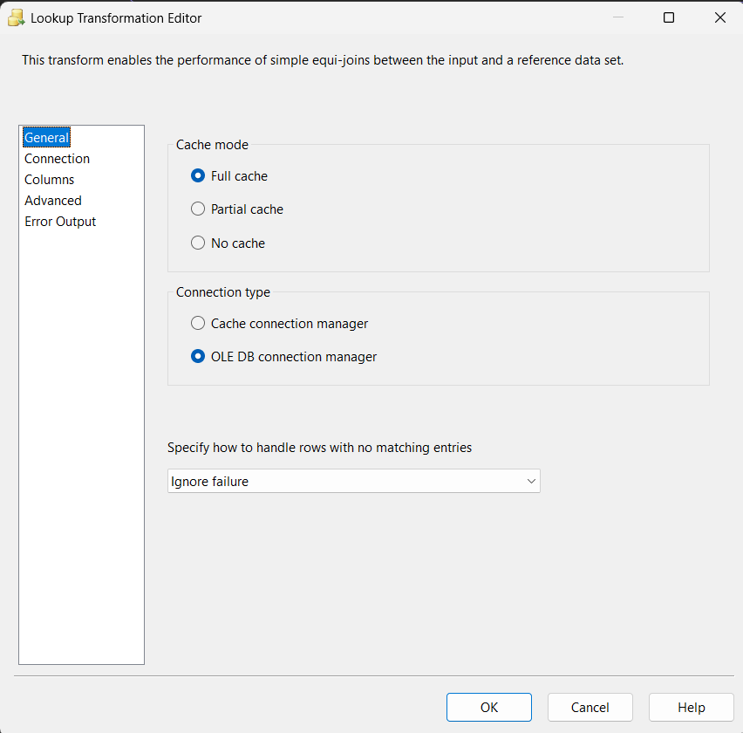
- Join Specification: Used to match with incoming ProductID and DIM_PRODUCT.To get ProductKey, use the ProductID.
- Transformation Parameters & Added Columns:
  - Lookup Column: CustomerKey
  - Lookup Operation: <add as new column>
  - Output Alias: CustomerKey
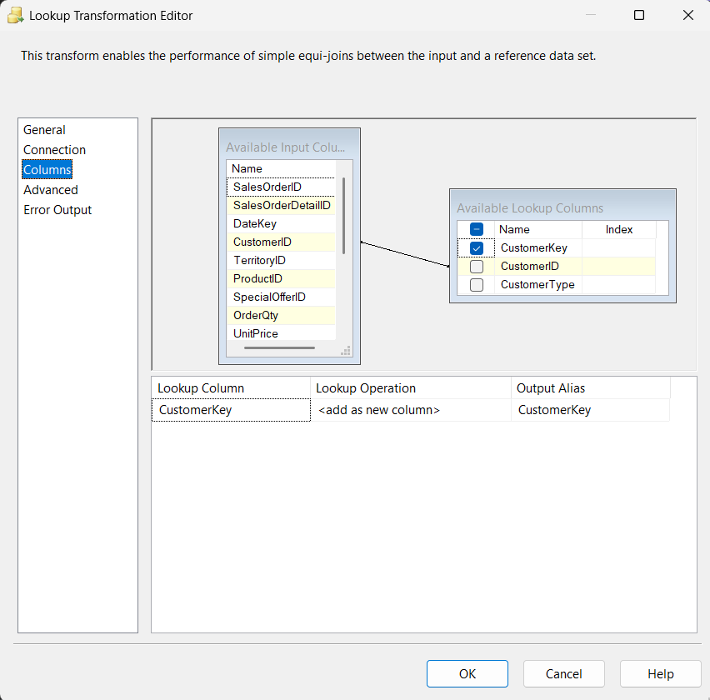
- Exception Handling & Routing Logic:
  - Configured with Ignore failure to avoid dropping transactions with unmapped consumer accounts.
  - Lookup Match Output: Directs enriched streams forward to the geographical territory resolution component (LookupTerritory).

8. Lookup Territory Transformation (LookupTerritory)
- Objective: Query DIM_CUSTOMER to isolate operational customers to standardized dimensions (CustomerKey) in the CustomerID.
- Caching Strategy: Full cache (in-memory reference caching for minimal I/O latency).
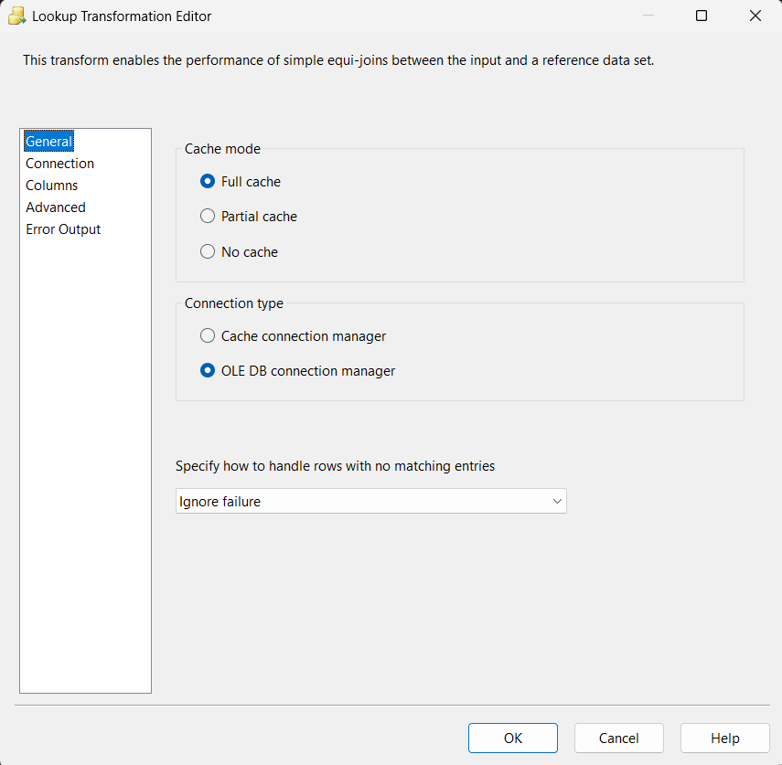
- Join Specification: Matches incoming TerritoryID against DIM_TERRITORY.TerritoryID to retrieve TerritoryKey.
- Transformation Parameters & Added Columns:
  - Lookup Column: TerritoryKey
  - Lookup Operation: <add as new column>
  - Output Alias: TerritoryKey
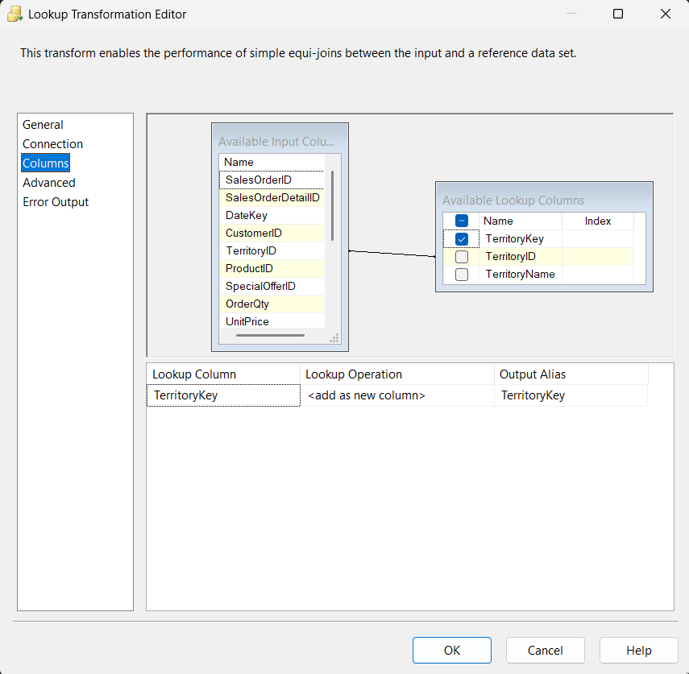
- Exception Handling & Routing Logic:
  - Configured with Ignore failure to protect execution flow from incomplete regional master data.
  - Lookup Match Output: Provides fully harmonized streams of transactions – that is, all of the 5 dimension foreign keys (such as DateKey, ProductKey, CustomerKey, TerritoryKey, PromotionKey) – directly into the final load stage (FactSalesLine).

9. OLE DB Destination (FactSalesLine)

Target Connection: LocalHost.DW_Promotion_Analytics.

Data Access Mode: Table or view - fast load (initiates optimized SQL Server Bulk Inserts for maximum write throughput).

Load Optimizations & Mappings:

Minimize locking and write bottlenecks during high-volume ingestion by reducing the number of potential null values and using Unchecked Check constraints.

Column SalesLineKey is set to <ignore> to allow automatic surrogate key generation via the database table's IDENTITY(1,1) property.

All dimensional foreign keys (DateKey, ProductKey, CustomerKey, TerritoryKey, PromotionKey) and calculated financial measures (GrossSales, DiscountAmount, NetSales) are all directly mapped into the target FACT_SALES_LINE table, without dropping any transactions (reconciled at 121,299 rows).
